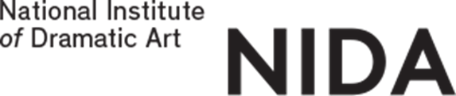
REFUND REQUEST FORM

HIGHER EDUCATION COURSES
Submit your completed form either in person to NIDA Student Services or by email to applications@nida.edu.au
Direct all refund enquiries to application@nida.edu.au
Please note: Refund requests may take up to four weeks to process.

Section 1 : Personal Details
Family Name: Given Names:
Date of Birth: __ /__ /__
Note: Students under 18 years of age must provide written consent from their parent/guardian approving the refund of payment. If written consent is not provided your refund cannot be processed.
NIDA Student ID: Telephone:
Email Address:
Address:
Original Payment Method:
________________________________________________________________________________________________________________________
Payment Date: _________________________________

Section 2: Declaration/Consent
I declare that the information declared on this form is complete and correct. I agree to the conditions of this refund and declare that I am the person to whom this refund is to be paid.
Signature:_______________________________________ Date:_____________________________

Section 3: Refund Payment Option
Refunds will be processed in Australian Dollars.
□ Cheque – Mailing Address if different from above address:
________________________________________________________________________________________

□ Direct Deposit into Bank Account (Funds Transfer). Please note: Overseas Bank Account Transfer may take up to six weeks.
BSB No: Bank Name:
Account No: Branch Address:
Account Name: Swift Code (overseas only):
………………………………………………………………………………………………………………………………………………………………………
STUDENT ADMINISTRATION USE ONLY:
Account Balance: Administration Fee: Refund Amount:
Prepared By: Authorised By: Processed by and date:

